J-Cinemas Ticketing System

# <J-Cinemas Ticketing System>

Software Requirements Specification

<1.0>

<9/18/2025>

<Group #4>

# <Jordan Kiryakoza, Justin Collett, Jonah Ale>

Prepared for

CS 250- Introduction to Software Systems

Instructor: Gus Hanna, Ph.D. Fall 2023

**Revision History**

## Date Description Author Comments

|  |  |  |  |
| --- | --- | --- | --- |
| 9/25/2025 | 1.0 | Jordan, Justin,  Jonah | <First Revision up to and  Including 3.5> |

|  |  |  |  |
| --- | --- | --- | --- |
|  |  | Jordan, Justin,  Jonah |  |
|  |  | Jordan, Justin,  Jonah |  |
|  |  | Jordan, Justin,  Jordan |  |

## Document Approval

The following Software Requirements Specification has been accepted and approved by the following:

### Signature Printed Name Title Date

|  |  |  |  |
| --- | --- | --- | --- |
|  | <Your Name> | Software Eng. |  |
|  | Dr. Gus Hanna | Instructor, CS 250 |  |
|  |  |  |  |

## Table of Contents

**REVISION HISTORY ...............................................................................................................................................II**

**DOCUMENT APPROVAL .......................................................................................................................................II**

1. **INTRODUCTION ................................................................................................................................................... 1**
   1. PURPOSE .............................................................................................................................................................. 1
   2. SCOPE

.................................................................................................................................................................. 1 1.3 DEFINITIONS, ACRONYMS, AND ABBREVIATIONS ................................................................................................ 3

1.4 REFERENCES

### ........................................................................................................................................................ 4 1.5 OVERVIEW ........................................................................................................................................................... 4

1. **GENERAL DESCRIPTION ...................................................................................................................................**

**4**

* 1. PRODUCT PERSPECTIVE ....................................................................................................................................... 5
  2. PRODUCT FUNCTIONS

.......................................................................................................................................... 5 2.3 USER CHARACTERISTICS ..................................................................................................................................... 5 2.4

ii

GENERAL CONSTRAINTS ...................................................................................................................................... 5

2.5 ASSUMPTIONS AND DEPENDENCIES

### ..................................................................................................................... 5

**3. SPECIFIC REQUIREMENTS ...............................................................................................................................**

**6**

### 3.1 EXTERNAL INTERFACE REQUIREMENTS ............................................................................................................... 6

*3.1.1 User Interfaces ............................................................................................................................................ 6*

*3.1.2 Hardware Interfaces ................................................................................................................................... 7*

*3.1.3 Software*

*Interfaces...................................................................................................................................... 8*

*3.1.4 Communications Interfaces ......................................................................................................................... 8*

3.2 FUNCTIONAL REQUIREMENTS .............................................................................................................................. 8 *3.2.1 <Functional Requirement or Feature #1> .................................................* ***Error! Bookmark not defined.***

*3.2.2 <Functional Requirement or Feature #2> .................................................* ***Error! Bookmark not defined.***

### 3.3 USE CASES ................................................................................................... ERROR! BOOKMARK NOT

**DEFINED.**

*3.3.1 Use Case #1 ................................................................................................* ***Error! Bookmark not defined.***

*3.3.2 Use Case #2 ................................................................................................* ***Error! Bookmark not defined.***

### 3.4 CLASSES / OBJECTS ............................................................................................................................................ 20

*3.4.1 <Class / Object #1> ..................................................................................................................................*

*20*

*3.4.2 <Class / Object #2> ..................................................................................................................................*

*20*

### 3.5 NON-FUNCTIONAL REQUIREMENTS ................................................................................................................... 21

*3.5.1 Performance .............................................................................................................................................. 21*

*3.5.2 Reliability .................................................................................................................................................. 22*

*3.5.3 Availability*

*................................................................................................................................................ 22*

*3.5.4 Security ..................................................................................................................................................... 22*

*3.5.5 Maintainability ..........................................................................................................................................*

*22*

*3.5.6 Portability ................................................................................................................................................. 22*

### 3.6 INVERSE REQUIREMENTS ................................................................................................................................... 23

3.7 DESIGN CONSTRAINTS .......................................................................................................................................

23 3.8 LOGICAL DATABASE REQUIREMENTS

................................................................................................................ 23 3.9 OTHER REQUIREMENTS ..................................................................................................................................... 23

**4. ANALYSIS MODELS ........................................................................................................................................... 23**

### 4.1 SEQUENCE DIAGRAMS ....................................................................................................................................... 23

4.3 DATA FLOW DIAGRAMS (DFD) .........................................................................................................................

23 4.2 STATE-TRANSITION DIAGRAMS (STD)

### .............................................................................................................. 23

**5. CHANGE MANAGEMENT PROCESS ............................................................................................................. 23**

1. **APPENDICES .......................................................................................................................................................**

**23**

A.1 APPENDIX 1....................................................................................................................................................... 24 A.2 APPENDIX 2....................................................................................................................................................... 24

iii

## 1. Introduction

The introduction section of the SRS establishes the infrastructure for the document as a whole by defining its purpose (1.1), scope (1.2), definitions, acronyms, and abbreviations (1.3), references (1.4), and overview (1.5) of the SRS for **J-Cinemas**, the movie ticketing system, including its intended audience. The purpose of this document is to act as a comprehensive blueprint, detailing all non-functional (defines how a system should perform) and functional (what the system does) requirements of developing a movie ticketing system.

### 1.1 Purpose

The movie ticketing system J-Cinemas' aim is to provide a convenient and smooth transactional account for the intended audience, the consumers, to search for movies, select their seats, and book their tickets online. By allowing the consumer to book online using our movie ticketing system at any given time, it can remove the need for standing in line at the physical affiliated location.

### 1.2 Scope

* The movie ticketing system, J-Cinemas, will function as a web-based application to facilitate the online ticket purchases for our local movie theater.
* J-Cinemas' objectives include accessibility, convenience, and efficiency for the movie theater ticket booking process.

The main purpose of J-Cinemas is to provide an alternative way for the user to purchase movie tickets. It will include functions such as user registration, movie listing browsing, seat selections, ticket booking, payment processing, and producing ‘e-tickets’ for user upon payment confirmation. On the admin side, it will include features for Admin role to manage movies and users’ accounts.

It will not include functions for purchasing food, drinks, or merchandise. It will also not include a review or ratings system that helps provide user-based feedback to customers to assist in determining movie choice(s). Processing refunds won’t be included in the MTS as it must be done in person at the box office location. Additionally, our movie ticketing system will not save users’ payment information into their account.

* **Benefit:** To successfully reduce the time for a customer to choose and purchase movie tickets by at least 40-50% compared to the manual physical system in standing in line at a movie theater’s physical location.
* **Objective:** Allow users to view all available seats in real-time, enabling them to purchase their preferred seats for a specific showtime for a movie within first 6 minutes (session timeout) of their interaction with the movie showtime’s seat selection window.

Our system should process movie ticket bookings and provide information to users in a set time frame (up to 1 month time frame before movies are shown). The MTS also needs to ensure and guarantee the security of user accounts as well as payment transactions and payment information. The MTS needs to be stable and available for users to interact with the website, browse movie listings, access their accounts, and book tickets without little to no interruptions from the system/server.

**User Registration:** Users can create account on our MTS website to be able to purchase movie tickets and get notifications about upcoming movie showtimes for tickets purchase. Admin will also need to create accounts so that they are provided with higher access to the website which will allow for modifications.

**Login:** Admin and users will log in to the website with their information. If successful, the page will refresh with the respected profile linked to the browser’s page with account details when clicked. If failed, then password re-attempt. (3 Attempts = Lockout)

**Change Password:** User can change their password by inputting correct responses to security questions.

**Movie Listings**: Users can browse movie selections by name and date, with movies displaying a short, summarized description of plot, runtime duration, and the MPA (Motion Picture Association) rating system.

**Ticket Booking –** Users can select movie and showtime from listings and book their ticket.

**Payment:** User will apply payment with [approved] credit card(s) via electronic payment system to confirm ticket booking.

**Ticket Confirmation:** After successful payment, user will receive an online electronic ticket that displays either a QR code or barcode, along with important information detailing: Movie name & Showtime, Seat Row & Number, and confirmation number receipt.

**Admin Functionalities:**

***Content Management***: Admin can add, modify, and remove movie information and showtimes.

**Theater and Seating Management:** Setting up seat placement configuration and movie showings for each individual theater screening room.

The goals of our MTS are to:

1. Provide a service that can be accessed at any given time for the user.
2. Promote the movies online that are to be shown in the box office.
3. Assist in profit increase by providing an alternative method for booking tickets.

#### 1.3 Definitions, Acronyms, and Abbreviations

***Definitions:***

**System:** J-Cinema, the web-based movie ticket booking foundation includes the user-based website (Front-end / what the users see) and the back end that is monitored and controlled by the admins that help operate it behind the scenes. (Back-end)

**User:** An individual that interacts with the system.

**Customer**: A guest OR registered user that can browse movie listings, purchase tickets, and check on their purchased movie ticket bookings. If registered users, then they have the ability to edit their account details, change password.

**Admin:** A specific type of user with high-access privileges that manages content of the system, including movies and showtimes, user accounts.

**Showtime:** A set of specific dates, times, and theater number for a given movie showing.

**Seat Selection / Layout**: A graphical or visual representation of the seats in a particular movie theater room. Shows whether or not the theater room has any availability based on whether or not a seat is available or already been purchased, or unavailable due to technical issues.

**Booking:** The system process of confirming a reservation of one (or more) seats for a specific movie and showtime.

**Payment Gateway**: Third-party service that is integrated within the system to securely process payment transactions.

**Transaction:** Process for making a payment for purchasing a movie ticket / reserving a seat at a movie booking.

**E-Ticket:** Electronic ticket that contains information of movie with either a QR code or barcode with seat and movie details, generated by system after ticket purchase confirmation.

***Acronyms and Abbreviations:***

**SRS:** Software Requirements Specification

**UI:** User Interface (For the user to interact with when on website, selecting seats, etc)

**DBMS:** Database Management System (Software that maintains the system’s database)

**API:** Application Programming Interface

**HTTPS:** Hypertext Transfer Protocol Secure

**PCI DSS:** Payment Card Industry Data Security Standard

**SQL:** Structured Query Language (Back-End)

**PDF:** Portable Document Format (Generating e-tickets)

**Platform:** Version of Windows or Apple (i.e. Windows 11, macOS) **OS:** Operating System (i.e. Android, iPhone) SMPT:

Simple Mail Transfer Protocol HTTP: Hypertext Transfer Protocol

### 1.4 References

3.0 System Requirements

3.1 External Interface Requirements

3.1.1 - User Interfaces

3.1.2 - Hardware Interfaces

3.2 - Functional Requirements

3.3 - Use-Cases

Titled: Use Cases

3.3.1 - Use Case #1 – Registering an account

3.3.2 - Use Case #2 – Account Login

3.3.3 - Use Case #3 – Purchasing tickets

3.3.4 - Use Case #4 – Browsing and selecting movie

3.4 - Classes & Objects

3.5 - Non Functional Requirements

### 1.5 Overview

The next section of this document, General Description, gives an overview of the functionality of the movie ticketing system, J-Cinema. It describes the informal factors and requirements used to help provide the background and framework for the technical requirements discussed in the subsequent chapter. It also includes the characteristics of the users (consumers) of JCinema.

The third section of this document, Specific Requirements, is more tailored towards the developers and explains the functionality of the movie ticketing system in more technical terms. While both sections of this document discuss the movie ticketing system as a whole

and describe J-Cinemas' functionalities, each section is intended for separate audiences and therefore explains each area in depth differently, using different language and terminology.

## 2. General Description

Our product, J-Cinema, will be a movie ticketing system that users will be able to interact with over the Web. They will be able to create an account and login to keep track of necessary information. They will be able to browse and search for movies to their liking. The user will be able to select a movie ticket for purchase, confirm it, and have their results displayed.

### 2.1 Product Perspective

This system shall be accessible through the web, and it is self-contained and doesn’t require any application or service to run besides an internet connection. It is a system that runs on its own designed to increase the discoverability of movies, and to increase the speed of buying tickets due to not having to go to a box office.

### 2.2 Product Functions

* The system shall have a user registration system so they can keep track of their purchases and spending.
* The system shall allow users to log in to the accounts they have created
* The system shall allow users to change their password had they forgotten or need to change it.
* The system shall allow users to search for movies, and sort in alphabetical order for easier findability
* The system shall allow users to add items to their cart
* The product shall have a cart that can hold up to 20 movie tickets at a time and allow the user to remove unwanted or duplicate tickets.
* The system shall allow users to purchase no more than 20 items per cart
* The system shall provide the user with an invoice for their purchase and confirmation after their purchase has been made.
* The system shall allow users to review their purchased history

### 2.3 User Characteristics

The users are expected to mainly be teenagers and young adults, with the exceptions of some parents and elders. We expect the users to either be in high school, have a diploma/degree, or be in the workforce. We expect the users to know how to use and manage basic technology, as that’s what the new generations are all about. We expect the users to not have much technical expertise, so we are designing our product to be as simple and easy to use as possible.

### 2.4 General Constraints

* Legal constraints must abide by laws regarding the users’ data as it often includes sensitive information such as a payment method.
* Database constraints, must be able to store users’ account data for all previous and active users.
* Age constraints, a user must be at least 18 to be able to digitally purchase a product in the system.
* Software constraints, the system shall be able to support up to 1,000 users. In the event that the system greatly surpasses that number, it could fail.
* Cost constraints, the development of this system cannot go over a certain cost threshold.

### 2.5 Assumptions and Dependencies

* Assume the users are accessing our system from a windows, mac, linux, apple, or android device
* We assume the users are accessing our system from Google Chrome, Opera, Microsoft Edge, Safari
* We assume that the required systems of the users are up to date, with at least 8gb of ram and a quad core processor.

## 3. Specific Requirements

### 3.1 External Interface Requirements

#### 3.1.1 User Interfaces

The system will provide a secure login and registration process for the users.

* Login window that has users enter a correct ID and password.

□ Upon successful login (approved authentication of data stored in user database ), user can edit their account details, purchase movie tickets, utilize rewards system.



□ If an account does not exist, the user must register a new account with their personal information to purchase tickets, utilize rewards system, check on



upcoming booked tickets, edit account details. Upon successful validation and creation (by the system) of account, users’ login information will be stored into the user database for potential future movie purchases.

* If password is incorrect, user can attempt 4 times before being locked out of account. User will need to reconfirm account through Forgot Password by inputting correct security question details in order to change password details.

The system will provide real-time seat availability for each movie and their respective showtimes. The users will be able to choose their preferred seats based on availability. The system will then update the seat availability in real-time to prevent potentially double bookings from additional users.

* Movie selection window for browsing and choosing through a list of movies and showtimes.

□ Clicking on a specific movie will open a new page, showing details of movie.



* + The system will include a brief synopsis, running time, and the associated MPA (Motion Picture Association) rating.
  + Underneath brief info will show clickable links in the form of Date & Showtimes for specific movie.
  + Clicking a specific showtime will load the seat selection window.
* Seat selection window for all movies and showtimes (individually) for users to choose their preferred seats based on selection availability.

□ Upon choosing a specific movie and showtime, the user will be loaded into seat selection window.



* + An interactive visual representation of a specific theater room’s layout will load showing both rows of each seat and number, allowing the user to choose their preferred seat(s), up to max limit of 20 seats.
  + When finished selecting seat(s), user will hit the Book Seats button which will direct user to a new page to prompt the user to choose the type of tickets based on their max number of seat selections in previous window.
  + The system will put a temporary hold on selected seats during the payment method transaction process.
* Ticket Choices Window

□ User will choose what types of tickets are being purchased. ▪ Child:



Ticket for children under 12

* + Adult: Ticket for people 12 and older (up to 59)
  + Senior: Ticket for people 60 and older
  + Matinee: **Only shows up for purchase if showtime is before 12 pm**

□ Confirming quantity and type of tickets and hitting Ok/Next button will take user to the payment method / transaction window.



The system will support secure payment processing using standard payment gateways. The users will be able to enter their payment information and finalize purchase transactions securely.

* Payment Method / Transaction window for inputting payment method information in to pay for movie ticket(s).

□ User will be required to input payment information including Full name, billing address, city, state, zip code. Will also include credit card number, expiration date, CVV(card verification value), and zip code the credit card is tied to.



* + User will also be prompt to choose between various credit card payment options (Visa, Mastercard)

□ Information is sent to payment gateway that sends a callback notification to the



ticketing system, which tells the system to mark the ticket booking as Confirmed.

□ The system releases the temporary hold on selected seats and updates seat availability and mark selected seats as now unavailable.



The system will provide a confirmation of ticket purchase bookings that is used as the reference for the user’s booking reservation.

* e-Ticket Generation / Email Confirmation

□ An alphanumeric code is generated by the system’s database to uniquely identify the movie ticket booking, which is linked to the user’s account, along with the rest of the ticket booking information.



□ An email confirmation displaying the code along with its respective barcode and seat details including: Theater Number, Row and Seat Number, and the date and time of movie showing.



▪ All booking information data is stored safely on the system’s database.

#### 3.1.2 Hardware Interfaces

* This product must be run over the internet. All hardware shall require connection to the internet either by Modem, Ethernet, LAN, etc.
* This product must be accessed using an electronic device, phone, tablet, computer, etc.
* This product shall allow users to navigate the system with their mouse and keyboard and or touch screen
* This product shall use the HTTP protocol when interacting with web servers
* This product shall interact with a SQL database to store and retrieve information
* This product shall use Email servers to send digital tickets and confirmation to the user.

#### 3.1.3 Software Interfaces

The system will use a database to store and retrieve user information. It will also implement an online payment service to process transactions. Lastly, the system will use an email service to send booking confirmations and password recovery information to users.

#### 3.1.4 Communications Interfaces

The system will use HTTPS for communication with web browsers and the payment service. Email communication will use SMTP.

### 3.2 Functional Requirements

#### 3.2.1 <User Registration feature>

3.2.1.1 Introduction –

* This feature will allow users to register an account for a movie ticketing system.

3.2.1.2 Inputs-

* The system shall accept a username or email
* The system shall accept a user’s full name
* The system shall accept a password that a user creates
* The system shall accept the user’s created password

3.2.1.3 Processing-

* The system shall validate that there are no empty fields
* The system shall verify that username and email are unique to avoid duplicates
* The system shall verify that the password and password confirmation match
* The system shall verify that the password meets password strength
* The system shall encrypt the password than store it in the database

3.2.1.4 Outputs-

* The system shall create a new user in the database
* The system shall display a success message to the user if registration is successful.
* The system shall redirect the user to the log in screen after registration is complete.

3.2.1.5 Error Handling-

* The system shall display “Username already in use” if username exists.
* The system shall display “Email already registered” if email exists.
* The system shall display “Password to weak” if password strength doesn’t meet requirements.
* The system shall display “Invalid email format” if email doesn’t match proper email format.
* The system shall display “The field is required” if a field is left empty.

#### 3.2.2 <User Login feature>

3.2.2.1 Introduction-

* This feature will allow users to log in to a movie ticketing system with their registered credentials.

3.2.2.2 Inputs-

* The system shall accept a username or email entered by the user
* The system shall accept a password entered by a user

3.2.2.3 Processing-

* The system shall validate that the username or email exists in the database
* The system shall verify that the password matches the stored encrypted password for the account
* The system shall reset the failed login counter if login was successful

3.2.2.4 Outputs-

* The system shall redirect the user to a home screen if the login is successful

3.2.2.5 Error Handling-

* The system shall lock the user out for 10 minutes after 4 failed login attempts

#### 3.2.3 <Password recovery feature>

3.2.3.1 Introduction-

* This system shall allow users to recover their password if they forgot

Page

3.2.3.2 Input-

* The system shall accept the registered email or username from the user
* The system shall accept a new password and confirm password for password reset

3.2.3.3 Processing

* The system shall validate whether the provided username or email exists in the database
* The system shall generate a single-use reset token with an expiration
* The system shall invalidate any previous active token

3.2.3.4 Outputs-

* The system shall display a confirmation message that a recovery link has been sent • The system shall send a password reset link

Page

* The system shall display a confirmation message after a successful reset
* The system shall send an email to confirm that the account has been reset

3.2.3.5 Error handling-

* The system shall display an error message if the email/username doesn’t exist
* The system shall display an error message if the token expires
* The system shall display an error message if the reset process fails
* The system shall block requests if too many recovery attempts were made in a short period of time

#### 3.2.4 <Online payment feature>

3.2.3.1 Introduction-

* This feature will allow users to make payments for movie ticket purchases

3.2.3.2 Input-

* The system shall accept the user’s payment information
* The system shall accept the user’s billing information
* The system shall accept the payment amount for the selected movie ticket

3.2.3.3 Processing

* The system must integrate with a third-party payment service (Stax) to handle transactions.
* The system must receive and interpret transaction responses from the payment gateway, such as success, failure, or pending statuses.
* The system shall validate whether the provided username or email exists in the database.
* The system shall validate the user’s payment and billing information.
* The system shall calculate the final ticket price.

3.2.3.4 Outputs –

* The system shall display the final ticket price
* The system shall display a confirmation message for a successful payment • The system shall generate a digital receipt

3.2.3.5 Error Handling-

* The system shall display an error message if payment gets declined
* The system shall display an error message if billing information is invalid
* The system shall mark booked seats as unavailable if payment is successful
* The system shall release seats back into availability if payment is unsuccessful
* The system shall log failed payment attempts for troubleshooting

#### 3.2.5 – <List movies & showtimes feature>

3.2.5.1 Introduction – This feature will allow users to browse and select movies based on their showtimes.

3.2.5.2 Input –

* The system shall accept the movie title that a user clicks on from the list or types in the search bar
* The system shall accept a date input from the user to filter out showtimes
* The system shall accept a location that a user chooses to watch a movie at

3.2.5.4 Processing

* The system shall search the database for movies that match the entered title
* The system shall filter out movies based on date and location
* The system shall gather the filtered results for displaying to a user

3.2.5.3 Output

* The system shall display a list of movies with corresponding showtimes
* The system shall display where the movie is available
* The system shall display an error message if no showtimes correspond to the selected movie

3.2.5.5 Error Handling

* The system shall display an error message if there are no matching results
* The system shall display an error message if the user enters an invalid date or location
* The system shall display an error message if the showtime is unavailable

#### 3.2.6 - <Seat selection feature>

3.2.6.1 Introduction- This feature will allow a user to select a seat for a given movie and showtime.

3.2.6.2 Input-

* The system shall accept an input for the seat a user selects
* The system shall accept the number of seats that a user wants to book

3.2.6.3 Processing-

* The system shall display a list of seats that for the selected movie and showtime
* The system shall ensure that the selected seats are available
* The system shall mark seats as reserved if a user selects them

3.2.6.4 Output-

* The system shall display a visual update for available and unavailable seats
* The system shall confirm that a seat was selected
* The system shall display a message to the user if a seat becomes unavailable before payment is processed

3.2.6.5 Error Handling-

* The system shall display an error message if the seat is already reserved
* The system shall display an error message if seat information fails to load due to a system error

#### 3.2.7<Ticket delivery feature>

3.2.7.1 Introduction – This feature will deliver purchased tickets to a user in a digital format.

3.2.7.2 Input –

* The system shall accept the users chose delivery method.
* The system shall accept the users contact information

3.2.7.3 Processing –

* The system shall create a digital ticket that displays movie title, showtime, seat selection, and a barcode
* The system shall update the database and mark the ticket as delivered once it is sent

3.2.7.4 Output –

* The system shall deliver the ticket to the users chosen delivery method
* The system shall display a confirmation message to ensure the ticket was delivered

3.2.7.5 Error Handling –

* The system shall display an error message if the ticket is not delivered due to system issues
* The system shall provide an alternative delivery method option if the initial delivery method fails

#### 3.2.8<Ticket history>

3.2.8.1 Introduction – This feature will allow users to view their history of tickets they purchased.

3.2.8.2 Input –

* The system shall accept filter inputs

3.2.8.3 Processing –

* The system shall get tickets that were purchased in the past that are associated with a user’s account

* The system shall filter out results according to the users input

3.2.8.4 – Output

* The system shall display a list of tickets that were purchased by the user in the past
* The system shall display the number of results
* The system shall display “No history” if no records are found

### 3.3 Use Cases 3.3.1 Use Case #1 Register for an account

|  |  |  |  |  |
| --- | --- | --- | --- | --- |
| Use Case #1 | Register for an account | | | |
| Goal in Context | This use case allows a user to create an account for a movie ticketing system. | | | |
| Preconditions | The user hasn’t created an account yet. | | | |
| Success End Condition | The user’s account gets created. | | | |
| Failed End Condition | The user’s account isn’t created and an error message is displayed. | | | |
| Primary Actor | User | | | |
| Secondary Actors | Authentication system, email service, database | | | |
| Trigger | The user clicks “Register account” or “Don’t have an account already” and provided their account details. | | | |
| Description |  | | | |
|  | Step | Action |  |
| 1      2 | The user clicks  “Register account”    The system displays  the registration  form |

|  |  |  |  |  |
| --- | --- | --- | --- | --- |
|  |  | 3        4        5          6            7 | The user fills out the registration form    The user submits the registration form    The system validates the details in the registration form    If validation is successful a confirmation message will be displayed    If validation is unsuccessful then an error message will be displayed |  |
| Extensions or Variations |  | | | |
|  | Step | Branching Action |  |

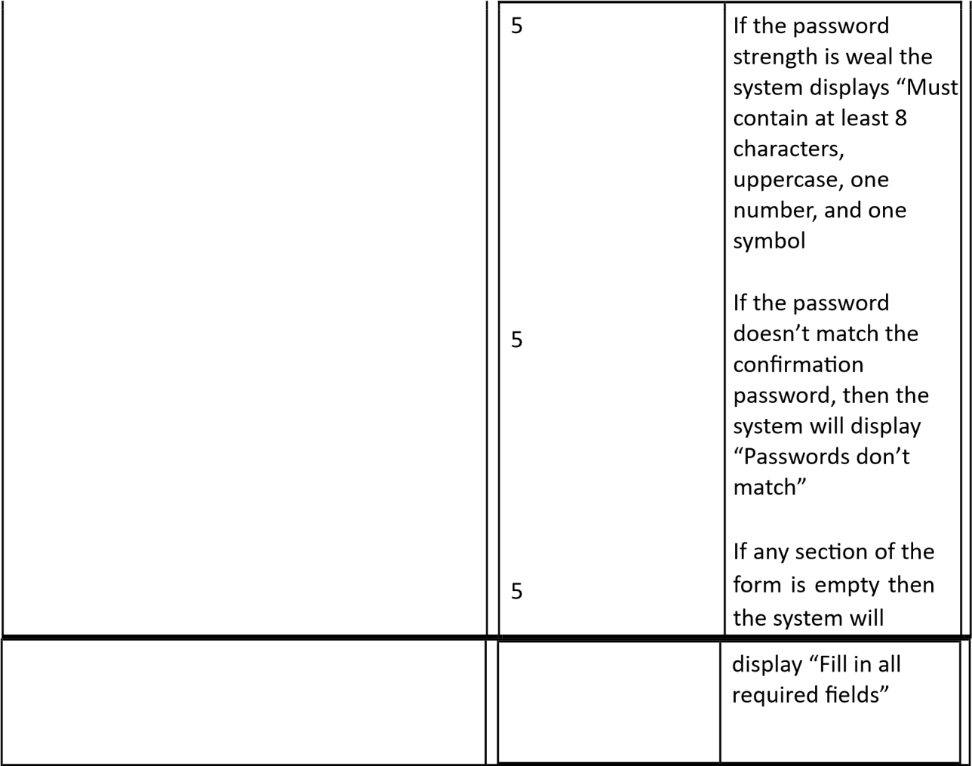

#### 3.3.2 Use Case #2 Log in to account

|  |  |  |  |  |  |
| --- | --- | --- | --- | --- | --- |
| Use Case #2 | Log in to account | | | | |
| Goal in Context | The user enters their username/email for their registered account. | | | | |
| Preconditions | The user has a registered account | | | | |
| Success End Condition | The user successfully logs into their account and is granted access to the system. | | | | |
| Failed End Condition | The user is not logged in due to incorrect account details. | | | | |
| Primary Actor | User | | | | |
| Secondary Actors | Authentication system, database, email/sms service | | | | |
| Trigger | User enters a username/email and password | | | | |
| Description |  | | | | |
|  | Step | | Action: |  |
| 1      2      3 | | User enters log in credentials    System validates log in credentials    System grants access to the system |
| Extensions or Variations | Step Branching Action | | | | |
|  | 2        2 | If log in credentials are invalid display an error message    If the user forgets their password redirect them to “Forgot password” recovery process | |  |
|  |  | 3 | If the user fails multiple attempts temporarily lock the account for 10 minutes | |  |

## Use Case #3: Pay for a ticket

|  |  |
| --- | --- |
| Use Case #3 | Pay for a ticket |
| Goal in Context | The user pays for a ticket for a given movie that they have selected. |
| Preconditions | The user has sufficient funds. |
| Success End Condition | The system validates payment successfully. |

|  |  |  |  |  |
| --- | --- | --- | --- | --- |
| Failed End Condition | The system declines the card due to insufficient funds. | | | |
| Primary Actor | Cardholder | | | |
| Secondary Actors | Alternate payment methods, the CardHolders bank | | | |
| Trigger | The cardholder provides banking information | | | |
| Description |  | | | |
| |  |  | | --- | --- | | Step | Action | | 1        2            3 | The user enters their banking/card information.    The system validates the banking/card  information    The payment goes through, and the ticket is purchased. | | | | |
| Extensions or Variations |  | | | |
| Step Branching Action | | | |
|  | 1 | If a user leaves a section empty, then display “Fill in all required fields” |  |
|  |  | 2          3 | If a user’s card declines then permit them to enter another card    If the payment fails due to system errors then display “System  is down at the moment” |  |

## Use Case #4 Browsing and selecting movies

|  |  |  |  |  |
| --- | --- | --- | --- | --- |
| Use Case #4 | Browsing and selecting movies | | | |
| Goal in Context | The user will browse a list of movies and then select a movie based on their preference. | | | |
| Preconditions | A user must be logged into their account. | | | |
| Success End Condition | A user’s movie selection is displayed when they click on it. | | | |
| Failed End Condition | A user’s movie selection is either buffered or doesn’t process due to system error. | | | |
| Primary Actor | A customer | | | |
| Secondary Actors | System, Movie database | | | |
| Trigger | A user clicks on the movie they selected | | | |
| Description |  | | | |
|  | Step | Action |  |
|  |  | 1        2 | The user clicks on a movie they selected.    A movie is displayed. |  |
| Extensions or Variations |  | | | |
|  | Step | Branching Action |  |
| 1        1 | The system displays movie details when a user hovers over a movie |
|  |  | 2              2 | The user clicks a movie that isn’t available so the system displays “The movie is not available”    The user cancels the movie before the movie loads and the system returns the user to the list of movies    The system loads the wrong movie because  of a database mismatch. The system notifies the user and asks them to try again. |  |

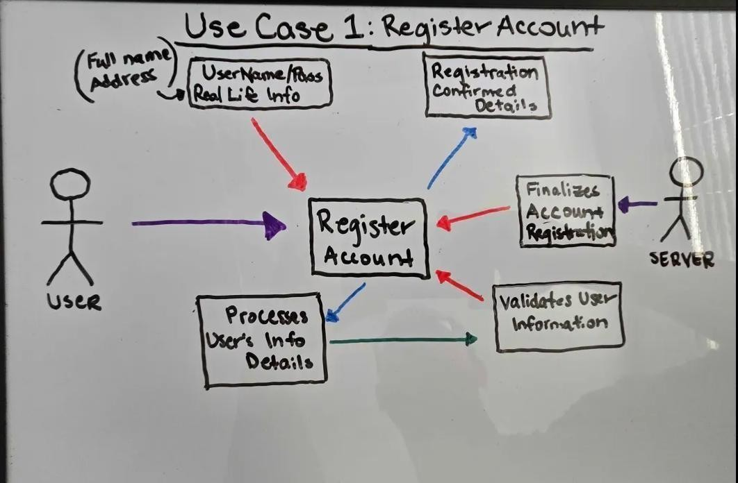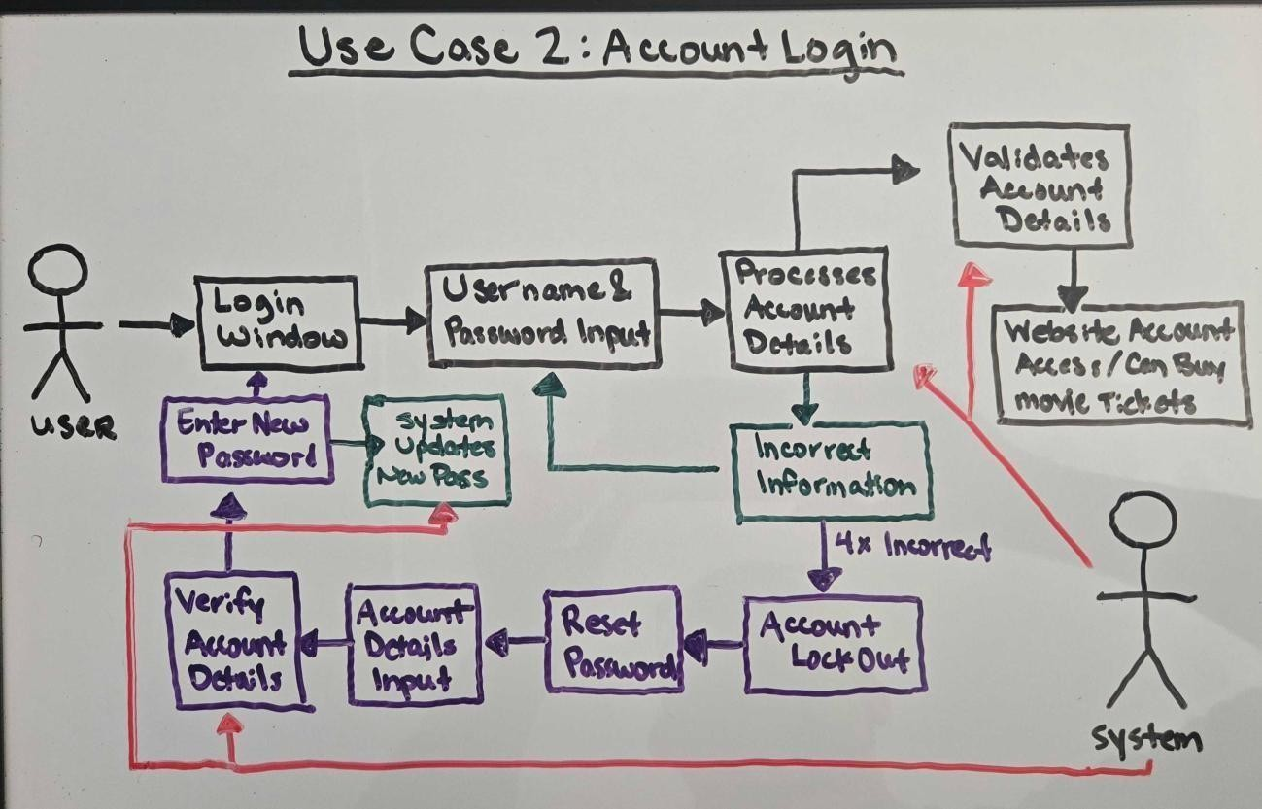

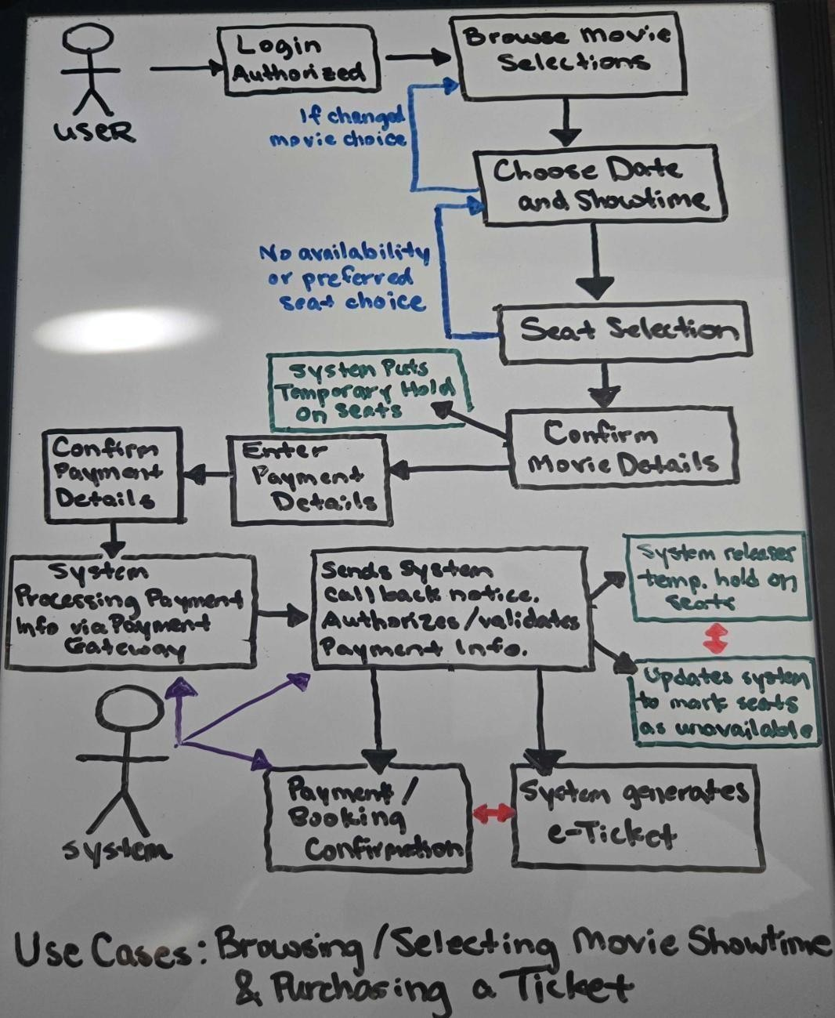

### 3.4 Classes / Objects

User class, Movie class, Showroom class, showtime class, booking class, seat class, theater class

#### 3.4.1 <User class>

Attributes: Username -> string, Password -> string

Objects: User objects

Functions: login(username, password)

#### 3.4.2 <Movie class>

Attributes: Title -> string, Genre -> string, Duration -> string, Rating -> double

Objects: Different types of films

Functions: AddMovie(title), DeleteMovie(title)

#### 3.4.3 <Theater class>

Attributes: Name -> String, Address -> String, Number of rooms -> int

Objects: Different theaters in the region

Functions: no functions

#### 3.4.4 <Showroom class>

Attributes: Room number -> int, Capacity -> int, Movie playing -> string, Seat-layout -> int, inherits movie class

Objects: Different showrooms.

Functions: Addmovie(title, Room Number), GetMovie(MoviePlaying)

#### 3.4.5 <Showtime class>

Attributes: Start time -> String, Movie Name -> String, Showroom number -> int,

#ofavailableseats -> int, Date -> string

Objects The different movie showing and their showrooms will be inherited to this class.

Functions: DisplayStartDate(Movie Name, ShowRoom number, Start time, Date) DisplayAvailableSteats(#ofavailableseats)

#### 3.4.6 <Seat class>

Attributes: Seat number -> int, Seat status -> string Objects: different seat numbers.

Functions: Getstatus(Seat number, Seat status)

#### 3.4.7 <Booking class>

Attributes: Inherits username, Room number, Capacity, Start time, Movie name, #ofavailable Seats, Seat number, Seat status

Objects: User object, Showroom object, Showtime object, Seat object, all used to verify and book the user.

Functions: BookUser(Username, Room number, Start time, Movie name, seat number)

ViewTicketStatus(Username, Room number, Start time, Movie name, seat number)

#### 3.4.8 <Payment class>

Attributes: paymentId, amount, payment method, status Objects: Each payment order connected to an order.

Functions: processPayment(orderId, amount, paymentmethod) confirmPayment(paymentId)

#### 3.4.9 <Ticket class>

Attributes: orderId, seatId, showtimeId, qrCode Objects: Individual tickets created for each booking.

Functions: generateQrCode(ticketId) validateQrCode(qrCode)

#### 3.4.10 <Notification class>

Attributes: userId, message, timestamp, datetime

Objects: Notification messages for booking cancellations, confirmations, or reminders.

Functions: sendNotification(userId, message), viewNotifications(userId)

#### 3.4.11 <Logging class>

Attributes: Inherits username, Room number, Capacity, Start time, Movie name, #ofavailable Seats, Seat number, Seat status

Objects: User object, Showroom object, Showtime object, Seat object, all used to verify and book the user.

Functions: BookUser(Username, Room number, Start time, Movie name, seat number)

ViewTicketStatus(Username, Room number, Start time, Movie name, seat number)

#### 3.4.11 <PaymentGateway class>

Attributes: gatewayName, apiEndpoint, status

Objects: Depicts the external payment gateway service integrated with the system.

Functions: startTransaction(orderId, amount), verifyTransaction(paymentId)

### 3.5 Non-Functional Requirements

#### 3.5.1 Performance

* The product shall be web based and must be run from a web server.
* The product shall have an initial load time that will vary depending on internet strength and the browser in which the user loads the system.
* The performance of the product shall depend on the client/customers internet strength, speed, and their hardware components.
* The product shall have an uptime of 95% or higher per day
* The product shall have a response time of less than 400 MS at any given point in the day.

#### 3.5.2 Reliability

* The product shall support up to 1000 users at once
* The product shall be processed in less than a second 95% of the time
* The product shall not crash upon too many instructions • The product shall maintain its speed given many active users
* The product shall be accessible anywhere in the U.S.

#### 3.5.3 Availability

Any and all information requested should be quickly available from any computer or phone’s web browser to the (authorized) registered user.

• Due to demand of seat availability, the system will not save progress for any user who logs out or closes the window in middle of the seat selection and / or payment transaction process.

* Forms of logging out include but not limited to: closure of J-Cinema browser page, exceeding the given time frame to finalize ticket bookings, or lost connection to server through any means.
* If no follow up activity from user after a set period of time of closing connection and not finalizing ticket booking, a periodic email will be sent to user’s email address on file in user’s account, suggesting to re-book the tickets or to have another look at other showtimes.

#### 3.5.4 Security

* The movie ticketing system is 100% accessible to only a secure authorized registered user account. This requires a username and password in order to be registered into the user database as an authorized user/member.
* The system will implement management of user sessions including session timeouts and re-authentication for operations involving sensitive information.
* Utilizes a secure payment processing system that handles sensitive payment information securely through the use of a payment gateway.
* The website also has implemented measures in place to ensure that only authorized users (registered accounts) can access specific functions and data.

#### 3.5.5 Maintainability

• The website is maintained such that any updates necessary to the movie ticketing system is managed through a backend system that is supported by the Admins, which controls and directs the information between the movie studios and the local theater.

o The updates for the system processes periodic changes including updated movie showtimes, new upcoming movies, and enables Admin-access accounts to adjust specific details.

#### 3.5.6 Portability

* The system shall be created to be run on any version of windows 10 or later.
* The movie ticketing web portal must be fully functional and render consistently across the latest stable versions of major web browsers, including Chrome, Firefox, Safari, and Edge.
* The system’s database plan and data must be compatible with SQL database systems to allow for migration.
* System backups must be restorable on a different hardware or software setup than the one in which they were created on.

**3.6 Inverse Requirements**

*State any *useful* inverse requirements.*

### 3.7 Design Constraints

*Specify design constraints imposed by other standards, company policies, hardware limitation, etc. that will impact this software project.*

### 3.8 Logical Database Requirements

*Will a database be used? If so, what logical requirements exist for data formats, storage capabilities, data retention, data integrity, etc.*

**3.9 Other Requirements**

*Catchall section for any additional requirements.*

## 4. Analysis Models

*List all analysis models used in developing specific requirements previously given in this SRS. Each model should include an introduction and a narrative description. Furthermore, each model should be traceable the SRS’s requirements.*

**4.1 Sequence Diagrams**

**4.3 Data Flow Diagrams (DFD)**

**4.2 State-Transition Diagrams (STD)**

## 5. Change Management Process

*Identify and describe the process that will be used to update the SRS, as needed, when project scope or requirements change. Who can submit changes and by what means, and how will these changes be approved.*

## 6. Software Design Specification

### 6.1 Software Architecture Overview

#### 6.1.1 Architectural Diagram of All Major Components

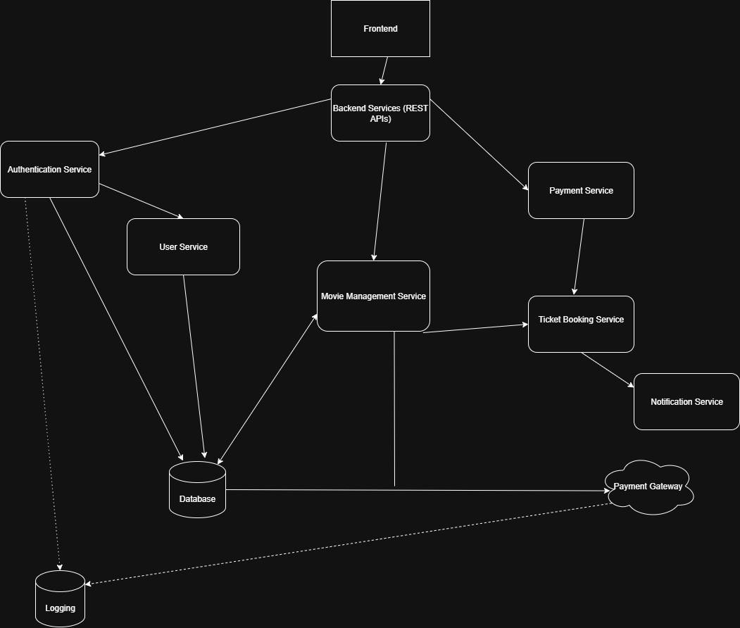

#### 6.1.2 UML Class Diagram

**6.1.3 Description of Classes:**

**6.1.3.1 <User Class> - Represents a customer that is registered in the system. It will handle authentication, folding profile info, and starting bookings and payments. It will interact with the Booking and Notification class, and will be verified by the authentication service before those interactions begin.**

**6.1.3.2 <Movie class> Represents a film that is currently available. Provides metadate used by the front end and by scheduling.**

**6.1.3.3 <Theater Class> Represents a venue that will have multiple rooms. Owns a collection of showrooms and provides location detail in terms of schedules and bookings.**

**6.1.3.4 <Showroom class> Represents an individual venue within a theater. Hosts showtimes for selected movies and contains many seats.**

**6.1.3.5 <Seat class> Represents a seating position within a showroom. Tracks availability/reservation status and is linked to a showtime when it is held or sold.**

**6.1.3.6 <Booking class> Represents the user’s purchase for one or more seats for a showtime. Will handle seat holds, price calculation, payment delivery, and creation of tickets if successful.**

**6.1.3.7 <Payment class> - Represents an internal record of the user’s transaction for a booking. Manages payment status and coordinate with the payment gateway for authorization.**

**6.1.3.8 <Ticket class> - Represents proof of purchase for a seat at showtime. Generate a successful payment and later validated.**

**6.1.3.9 <Notification class> - Represents messages that are sent to a user. It is triggered by events such as booking or payment.**

**6.1.3.10 < PayementGateway class> Represents the payment gateway provider. Handles API calls to authorize, confirm, and refund payments and will provide details to the payment process.**

**6.1.4 Description of Attributes –**

**Username – The unique identifier assigned to a user for login.**

**Password- The confidential key that user uses to access their account.**

**Title – The name of the movie.**

**Genre – The category of the movie.**

**Duration – The overall running time of the movie.**

**Rating – The quality score of the movie.**

**Name – The title of the theater location.**

**Address – The location of the theater.**

**Number of rooms – The number of auditoriums/showrooms within the theater.**

**Room number – The label that pertains to a showroom.**

**Capacity – The overall number of available seats.**

**Movie playing – The movie currently being played in the showroom.**

**Seat-layout – The scheduled arrangement in the showroom.**

**Start time – The scheduled time for when the movie starts.**

**Showroom number – Identifies the showroom where the movie is being played**

**#ofavailableseats – The number of remaining seats available for booking.**

**Date – The date the movie is being shown.**

**Seat number – The specific seat assigned for a viewer.**

**Seat status = The seat that is available, reserved, or occupied.**

**PaymentId – A unique code that depicts a payment transaction.**

**Amount – The total cost of the booking or order.**

**Payment method – The method of payment being used.**

**Status – The state of the transaction.**

**OrderId – The reference ID that pertains to a ticket that also pertains to a particular booking.**

**SeatId – The unique code that a seat is assigned to in the database.**

**ShowtimeId – Links a ticket or booking to a showtime.**

**QrCode – A digital code created for scanning and validating a ticket.**

**UserId – Identifies the user associated with a notification.**

**Message – The content of the notification.**

**Timestamp – The time a notification is created.**

**Datetime – A record of the date and time of an event.**

**GatewayName – The name of the external payment system that is used.**

**ApiEndpoint – The path that is used to sent data to a payment service.**

**Status – Indicates the status of the payment gateway.**

**6.1.5 Description of Operations**

## A. Appendices

*Appendices may be used to provide additional (and hopefully helpful) information. If present, the SRS should explicitly state whether the information contained within an appendix is to be considered as a part of the SRS’s overall set of requirements.*

*Example Appendices could include (initial) conceptual documents for the software project, marketing materials, minutes of meetings with the customer(s), etc.*

**A.1 Appendix 1**

### A.2 Appendix 2